MCP - Model Context Protocol

Table of Contents
Setup 2
Overview 3
Versions 3
Tool Using Models 4
MCP Tools and Resources 5
MCP Server Scripts for Tools 6
System Health MCP 8
Network Ping MCP 9
Calling Tools 11
MCP Resources 14
MCP Tool and Resource Calling 17
MCP Server with Bottle Web App Framework 18
MCP Server for Claude Desktop 19

This class teaches the basic concepts of building MCP (Model Context Protocol) Servers to provide AI systems tools. MCP is like a REST API for AI and anything you can write as a Python function can be accessed by your AI system.

Setup
Install Ollama
Ollama must be running on the local machine.for the projects to work.
Ollama.com

Pull a model with Tool Calling capabilities. IBM Granite4.1:3b should work on most laptop computers, but may have quirky results. gemma4:31b provides good results but requires a system with 32 GB of RAM.
You can also use MCP with API calls to AI services such as OpenAI’s API.
ollama pull granite4.1:3b

python3 -m pip install ollama

Install MCP Module
python3 -m pip install mcp

Note:
Some Models with Tool calling capabilities may not work with the demonstrations shown in this class. Granite4.2:3b uses chain-of-thought which may confuse the model on how to implement tools.
DEMO SCRIPT USING granite4.2:3b vs 4.1

Overview

MCP or Model Context Protocol is like an API for AI systems. This is a client/server architecture where an AI systems asks the MCP server for a list of it’s tools, and then picks one of those tools to use.
MCP Servers can also offer read only resources that can be used by AI Agents such as instructions, or documentation for answering queries.
MCP Servers can be connected to with Python scripts, or with applications such as Anthropic Claude Desktop.
MCP Servers can be full fledged network connected servers using a web app framework such as FastAPI, or can be a local Python script for your AI system to directly use without using TCP/IP.

Versions
MCP is currently on Version 2.0.
MCP was created by Anthropic and released November 2024.
Version 2 offers a number of improvements, and should be used instead of version 1.
Version 1 used FastMCP function and version 2 uses MCPServer.
MCP 1.0
from mcp.server.fastmcp import FastMCP

MCP 2.0
from mcp.server.mcpserver import MCPServer

MCP uses JSON-RPC 2.0 as its message format — requests have a method, optional params, and an id; responses have matching ids with either a result or error.
In MCP over HTTP, the client and server go through these steps, which match the server you just have:
- Initialize (client → server): The client sends an initialize request with its protocol version and capabilities.
- Initialize response (server → client): The server replies with its protocol version, its capabilities (here, tools), and its name and version.
- Initialized notification (client → server): The client sends notifications/initialized. It has no id, so the server doesn't reply. This is why the code returns 202 for messages without an id.
- Discovery (client → server): The client sends tools/list, and the server returns each tool's name, description, and input schema.
- Invocation (client → server): When the model wants a tool, the client sends tools/call with the tool name and arguments.
- Result (server → client): The server runs the tool and returns the output as content, such as [{"type": "text", "text": "14:32:05"}].

Tool Using Models
You will have to use a model that explicitly states that it can use tools. Models can also have varying degrees of compatibility with MCP.

MCP Tools and Resources
An MCP Server is able to provide both Tools and Resources to AI Applications.
Tools are function calls that the AI System can make. After you make a request of your AI system it will query the MCP Server for a list of tools. You AI will then call the tool it finds approriate which will trigger the function on the MCP Server. The AI will then take the response from the servers function call and use it’s model to provide an answer to the user.
Resources are Read Only Data that the MCP Server can provide and will be called by the Application and not the AI LLM.

MCP Tool Example
@mcp.tool()
def get_time() -> str:
"""Return the current time (HH:MM:SS)."""
return datetime.now().strftime("%H:%M:%S")

MCP Resource Example
@mcp.resource("hours://business")
def get_business_hours() -> str:
"""Provides the current hours of operation for the business."""
return (
"Store Hours of Operation:\n"
"Monday - Friday: 9:00 AM - 6:00 PM\n"
"Saturday: 10:00 AM - 4:00 PM\n"
"Sunday: Closed"
)

MCP Server Scripts for Tools
DEMO: mcp-basic-client.py
Run client script to that it can access tools for time and day of week.

To create tools for your MCP Server you import the MCPServer function from the mcp module. You then create functions with an mcp function decorator.
If you do not state a name for the tool then the name of the function will automatically be used. You can also add a description within a string inside the main function.
To explicitly set a name and description you can do so within the arguments for the tool decorator. The name should use snake case naming with additional punctuation such as this_is_a_really_cool_function.
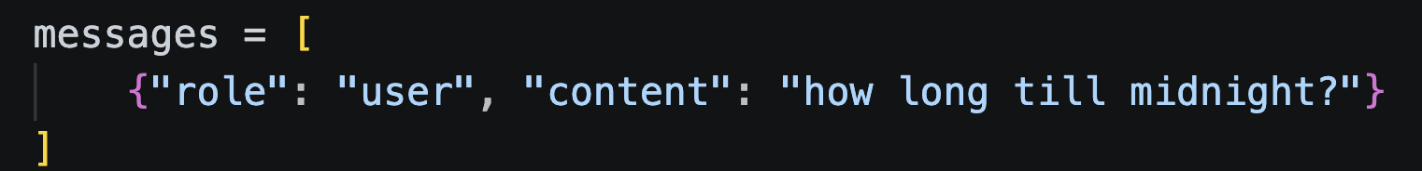
python3 -m pip install mcp

mcp-server-basic.py
from datetime import datetime
from mcp.server.mcpserver import MCPServer

mcp = MCPServer("time-server")

@mcp.tool()
def get_time() -> str:
"""Return the current time (HH:MM:SS)."""
return datetime.now().strftime("%H:%M:%S")

@mcp.tool()
def get_day_month_year() -> str:
"""Return the current day of the week."""
return datetime.now().strftime("%A, %B, %Y")

if __name__ == "__main__":
mcp.run()
mcp-server-basic-full.py
from datetime import datetime
from mcp.server.mcpserver import MCPServer

mcp = MCPServer("time-server")

@mcp.tool(
name="Get_Current_Time",
description="Return the current time in HH:MM:SS (24-hour) format, based on the server's local clock.",
)
def get_time() -> str:
return datetime.now().strftime("%H:%M:%S")

@mcp.tool(
name="Get_Day_Month_And_Year",
description="Return the current day of the week (e.g. 'Monday'), based on the server's local clock.",
)
def get_day_month_year() -> str:
return datetime.now().strftime("%A, %B, %Y")

if __name__ == "__main__":
mcp.run()

System Health MCP
This MCP Server allows you query your AI about your system status. We have 3 tools that use OS level applications to pull data about your system. We use TOP to access data about CPU and RAM usage, PING to see the status of your internet connection and DF to see how much of your storage is used.
This eaxmple shows you how you can give access to your Operating System to your AI Application.
mcp-server-system-health.py
import subprocess

from mcp.server.mcpserver import MCPServer

mcp = MCPServer("System-Monitor")

@mcp.tool()
def get_system_health() -> str:
"""Return the output of the Top command to show CPU and Memory usage of system"""
result = subprocess.run(['top', '-l', '1', '-n', '0'], capture_output=True, text=True)
return result.stdout

@mcp.tool()
def get_network() -> str:
"""Return the Ping results from google.com"""
result = subprocess.run(['ping', '-c', '1', 'google.com'], capture_output=True, text=True)
return result.stdout

@mcp.tool()
def get_storage() -> str:
"""Return the Utilization of the Local hard Drive"""
result = subprocess.run(['df', '-h', '/'], capture_output=True, text=True)
return result.stdout

if __name__ == "__main__":
mcp.run()

Network Ping MCP
This example provides multiple tools that can be used by your client script. You can ask you script to “ping cnn.com” and it willuse multiple tools to solve the problem. It will pull out cnn.com as the argument for resolve_ip() to get it’s IP address, and then will use ping_ip() to ping the address. If you provide an IP Address then extract_ip() will try to get the IP to provide to the ping_ip() function.

mcp-server-ping.py
import ipaddress
import platform
import re
import socket
import subprocess
from mcp.server.mcpserver import MCPServer

mcp = MCPServer("network-tools")

IPV4_PATTERN = re.compile(r"\b(?:\d{1,3}\.){3}\d{1,3}\b")

@mcp.tool()
def extract_ip(text: str) -> str:
"Find and return the first valid IPv4 address in a block of text."
for candidate in IPV4_PATTERN.findall(text):
try:
ipaddress.IPv4Address(candidate) # rejects things like 999.1.1.1
return candidate
except ValueError:
continue
return "Error: no valid IPv4 address found in the text."

@mcp.tool()
def resolve_ip(hostname: str) -> str:
"Resolve a hostname or domain (e.g. google.com) to its IPv4 address."
try:
return socket.gethostbyname(hostname)
except socket.gaierror as e:
return f"Error: could not resolve {hostname}: {e}"

@mcp.tool()
def ping_ip(ip: str, count: int = 4) -> str:
"Ping an IP address and return the ping output."
try:
ipaddress.ip_address(ip) # validate so arbitrary input never reaches the shell
except ValueError:
return f"Error: {ip!r} is not a valid IP address."

flag = "-n" if platform.system() == "Windows" else "-c"
count = max(1, min(count, 10))
try:
proc = subprocess.run(
["ping", flag, str(count), ip],
capture_output=True, text=True, timeout=30,
)
return proc.stdout or proc.stderr
except subprocess.TimeoutExpired:
return "Error: ping timed out."

if __name__ == "__main__":
mcp.run()

Calling Tools
When you use your AI script to call tools it has the ability to call a number of tools at a time. So if you use the mcp-ping-server.py MCP Server you can ask it to ping cnn.com and it will use a tool to get the IP Address of cnn.com and then another to ping it.
You can even ask if cnn.com has better latency than fox.com and it will get the IP Addresses for both sites, pig both sites and then with the response will give you an answer.
In the for loop we set a maximum tool call of 10 in case it gets into an inescapable loop, and then the responses are appended to the message list so that the AI has access to all previous responses.
Note: Depending on what you’re asking models may work well, or fail in odd ways. Granite4.1:3b can tell you the time, but if you ask how long till midnight the answer will be wildly off. Gemma4:31b works well for more complicated queries.
mcp-client.py
import asyncio
import ollama
import subprocess
from mcp import ClientSession, StdioServerParameters
from mcp.client.stdio import stdio_client

# must support tool calling - gemma4:31b - granite4.1:3b
OLLAMA_MODEL = "gemma4:31b"
MCP_SERVER = "mcp-ping-server.py"
# mcp-server-basic-full.py
# mcp-server-system-health.py
# mcp-server-ping.py

server_params = StdioServerParameters(
command="python3",
args=[MCP_SERVER], # path to your MCP server script
)

def mcp_tools_to_ollama_format(mcp_tools):
tools = []
for t in mcp_tools:
tools.append({
"type": "function",
"function": {
"name": t.name,
"description": t.description or "",
"parameters": t.input_schema or {"type": "object", "properties": {}},
},
})
return tools

async def query_ai(query):
async with stdio_client(server_params) as (read, write):
async with ClientSession(read, write) as session:
await session.initialize()

# Discover available tools from the MCP server
tools_result = await session.list_tools()
ollama_tools = mcp_tools_to_ollama_format(tools_result.tools)

### ADD RESOURCE CODE HERE

messages = [
{
"role": "system",
"content": "You are a helpful assistant with access to local system tools and automation. "
"Use the provided tools to answer the user's request whenever necessary. "
"Be brief"
},
{"role": "user", "content": query}
]
for _ in range(10):

response = ollama.chat(
model=OLLAMA_MODEL,
messages=messages,
tools=ollama_tools,
)

msg = response["message"]
messages.append(msg)

# If the model wants to call tools, execute them via MCP
if msg.get("tool_calls"):
for call in msg["tool_calls"]:
name = call["function"]["name"]
args = call["function"]["arguments"]

result = await session.call_tool(name, arguments=args)
tool_output = "".join(
c.text for c in result.content if hasattr(c, "text")
)

messages.append({
"role": "tool",
"content": tool_output,
"name": name,
})

# Send tool results back to the model for a final answer
final = ollama.chat(model=OLLAMA_MODEL, messages=messages)
result = final["message"]["content"]
print('--- TOOLS')
print(ollama_tools)
print('--- TOOL CALL')
print(response)
print('--- TOOL RESPOSE')
print(tool_output)
print('--- LLM RESPONSE')
print(final)

else:
result = msg["content"]
return result

while True:
query = input('Query About System: ')
subprocess.run(['clear']) # Clear screen
response = asyncio.run(query_ai(query))
print(query)
print(response)
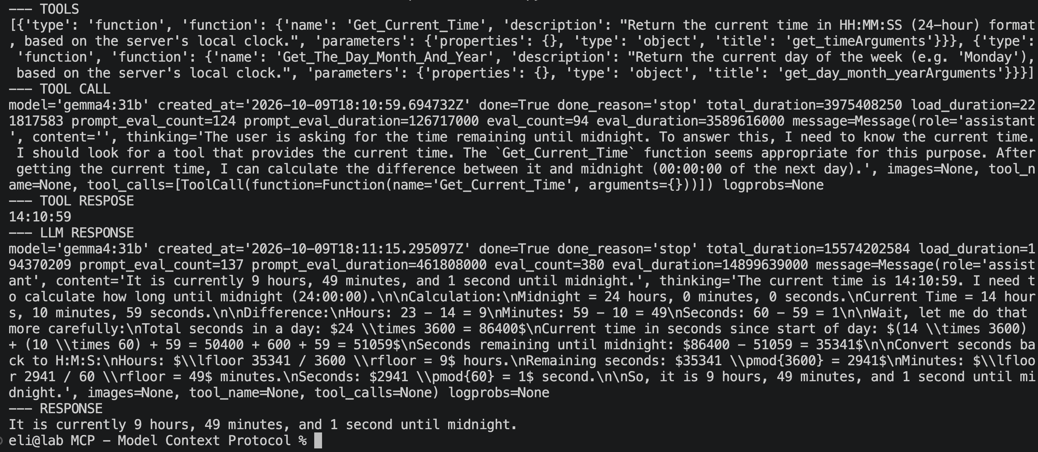

MCP Resources
MCP Resources are Read Only Data that you can use to add additional context to your queries. Resources are called directly by the script and identified by their URI (hours://business).
For URI (Universal Resource Identifier) if you offer a string you can siply use word1://word2.
mcp-server-resource-hours.py
from mcp.server.mcpserver import MCPServer

mcp = MCPServer("Business Hours Server")

@mcp.resource("hours://business")
def get_business_hours() -> str:
"""Provides the current hours of operation for the business."""
return (
"Store Hours of Operation:\n"
"Monday - Friday: 9:00 AM - 6:00 PM\n"
"Saturday: 10:00 AM - 4:00 PM\n"
"Sunday: Closed"
)

if __name__ == "__main__":
mcp.run()

mcp-client-resource-hours.py
import asyncio
from mcp import ClientSession, StdioServerParameters
from mcp.client.stdio import stdio_client

async def main():
server_params = StdioServerParameters(
command="python3",
args=["mcp-server-resource-hours.py"] # Ensure server.py is in the same folder
)

async with stdio_client(server_params) as (read, write):
async with ClientSession(read, write) as session:
await session.initialize()

print("--- Requesting Business Hours ---")

resource_uri = "hours://business"
result = await session.read_resource(resource_uri)

content = result.contents[0].text
print(f"Server responded with:\n\n{content}")

if __name__ == "__main__":
asyncio.run(main())

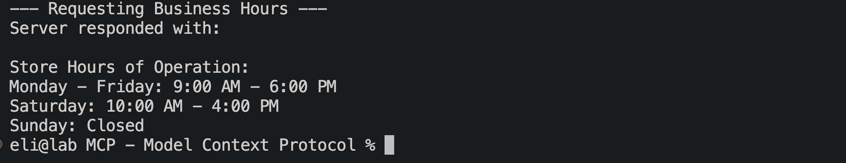
This script adds AI functionality to be able to ask questions and receive responses based on the resource. Be aware that different models are able to give better or worse answers.
mcp-resource-hours-ollama.py
import asyncio
import ollama
from mcp import ClientSession, StdioServerParameters
from mcp.client.stdio import stdio_client

async def main():
server_params = StdioServerParameters(
command="python3",
args=["mcp-server-resource-hours.py"]
)

async with stdio_client(server_params) as (read, write):
async with ClientSession(read, write) as session:
await session.initialize()

user_query = input("Ask a question about the business: ")

resource_uri = "hours://business"
resource_result = await session.read_resource(resource_uri)
business_hours_context = resource_result.contents[0].text

prompt = f"""
You are a helpful business assistant. Use the following context to answer the user question.
If the answer isn't in the context, say you don't know.

CONTEXT:
{business_hours_context}

USER QUESTION:
{user_query}
"""
response = ollama.chat(model='granite4.1:3b', messages=[
{
'role': 'user',
'content': prompt,
},
])

print(response['message']['content'])

if __name__ == "__main__":
asyncio.run(main())

MCP Tool and Resource Calling
You can add resources to your MCP Powered AI Script to provide context to the responses your scripts return. In this example we provide Qualtiy of Service values for RTC, Standard Internet and Bad Internet. The AI Script can the get the Latency from the Ping command and then compare the value against the resource values.
mcp-server-client-ping.py
# ADD RESOURCE BLOCK AFTER OLLAMA_TOOLS AND BEFORE MESSAGES =
# TO MCP-CLIENT.PY SCRIPT
… … …
ollama_tools = mcp_tools_to_ollama_format(tools_result.tools)

resource_uri = "latency://quality"
resource_result = await session.read_resource(resource_uri)
context = resource_result.contents[0].text
query = f'{query}\n CONTEXT \n {context}'

messages = […… …. ….

mcp-server-ping.py
# ADD TO END OF MCP-PING-SERVER.PY SCRIPT BEFORE RUN()

@mcp.resource("latency://quality")
def get_latency() -> str:
"""Provides quality of service for latency."""
return (
"> 30 ms is good for RTC\n"
"30 to 90 ms is good for Standard Internet\n"
"Over 100 ms is a bad connection\n"
)

MCP Server with Bottle Web App Framework
You can build an MCP Server that will provide Tools and Resources to internet/network clients using a Web App Framework such as Bottle. (We use Bottle generally for projects. You can use FastAPI, Django or any other web app framework)
For a client script to connect to it you will have to use the streamable_http_function. 3 lines have to be edited form the standard client script we have been using.
NOTE: You will have to start the server script in it’s own terminal window, and the client script will have to run in a different one.
mcp-client-bottle.py
# from mcp.client.stdio import stdio_client
from mcp.client.streamable_http import streamable_http_client
…
MCP_SERVER = "http://localhost:8080/mcp"
# MCP_SERVER = "mcp-ping-server.py"
…
async def query_ai(query):
async with streamable_http_client(MCP_SERVER) as (read, write):
# async with stdio_client(server_params) as (read, write):

In the server script you will define you functions that will be avilable as MCP tools. You will then create a TOOLS{} dictionary that will provide information about the Tools to the client. In the for the handeer: key you will point it to the local function. You can also add lambda functions here.

mcp-server-bottle.py
from datetime import datetime, timezone
import json
from bottle import Bottle, request, response

app = Bottle()

SERVER_INFO = {"name": "bottle-time-date-mcp", "version": "1.0.0"}
PROTOCOL_VERSION = "2024-11-05"

# ---------------------------------------------------------------------------
# Tool implementations
# ---------------------------------------------------------------------------

def get_time(args):
fmt = args.get("format", "%H:%M:%S")
use_utc = args.get("utc", False)
now = datetime.now(timezone.utc) if use_utc else datetime.now()
return now.strftime(fmt)

def get_date(args):
fmt = args.get("format", "%Y-%m-%d")
use_utc = args.get("utc", False)
now = datetime.now(timezone.utc) if use_utc else datetime.now()
return now.strftime(fmt)

TOOLS = {
"get_time": {
"description": "Get the current time. Optionally pass a strftime "
"'format' string and/or 'utc': true.",
"inputSchema": {
"type": "object",
"properties": {
"format": {"type": "string", "description": "strftime format string"},
"utc": {"type": "boolean", "description": "Use UTC instead of local time"},
},
},
"handler": get_time,
},
"get_date": {
"description": "Get the current date. Optionally pass a strftime "
"'format' string and/or 'utc': true.",
"inputSchema": {
"type": "object",
"properties": {
"format": {"type": "string", "description": "strftime format string"},
"utc": {"type": "boolean", "description": "Use UTC instead of local time"},
},
},
"handler": get_date,
},
}

# ---------------------------------------------------------------------------
# JSON-RPC / MCP plumbing
# ---------------------------------------------------------------------------

def rpc_result(id_, result):
return {"jsonrpc": "2.0", "id": id_, "result": result}

def rpc_error(id_, code, message):
return {"jsonrpc": "2.0", "id": id_, "error": {"code": code, "message": message}}

def handle_initialize(id_, params):
return rpc_result(id_, {
"protocolVersion": PROTOCOL_VERSION,
"capabilities": {"tools": {}},
"serverInfo": SERVER_INFO,
})

def handle_tools_list(id_, params):
tools = [
{"name": name, "description": t["description"], "inputSchema": t["inputSchema"]}
for name, t in TOOLS.items()
]
return rpc_result(id_, {"tools": tools})

def handle_tools_call(id_, params):
name = params.get("name")
args = params.get("arguments", {}) or {}
tool = TOOLS.get(name)
if tool is None:
return rpc_error(id_, -32602, f"Unknown tool: {name}")
try:
text = tool["handler"](args)
except Exception as exc: # pragma: no cover
return rpc_error(id_, -32000, f"Tool execution failed: {exc}")
return rpc_result(id_, {"content": [{"type": "text", "text": text}]})

METHODS = {
"initialize": handle_initialize,
"tools/list": handle_tools_list,
"tools/call": handle_tools_call,
}

@app.post("/mcp")
def mcp_endpoint():
response.content_type = "application/json"
try:
payload = request.json
except Exception:
payload = None

if not payload:
return json.dumps(rpc_error(None, -32700, "Parse error"))

id_ = payload.get("id")
method = payload.get("method")
params = payload.get("params", {}) or {}

handler = METHODS.get(method)
if handler is None:
return json.dumps(rpc_error(id_, -32601, f"Method not found: {method}"))

return json.dumps(handler(id_, params))

@app.get("/health")
def health():
return {"status": "ok", "server": SERVER_INFO}

if __name__ == "__main__":
app.run(host="localhost", port=8080, debug=True)

MCP Server for Claude Desktop
You can use MCP Server scripts for both Tools and Resources in Claude Desktop and other AI applications. They can be hosted remotely as a standard server service or local be accessed locally like a standard script.
You will have to edit the JSON configuration file to add a local MCP script to your Claude setup.
Open Claude Desktop, go to Claude → Settings → Developer → Edit Config. It opens Finder at the file.

Direct path:
~/Library/Application Support/Claude/claude_desktop_config.json

Add To Top of JSON file after first {
- my-server is name for MCP server
- command is for command to run Python
- args is for path to MCP script
"mcpServers": {
"my-server": {
"command": "python3",
"args": [
"/Users/eli/Library/Mobile Documents/com~apple~CloudDocs/#Silicon Dojo/#Projects/MCP/mcp-system-health-server.py"
]
},
"snail-poetry": {
"command": "python3",
"args": [
"/Users/eli/Library/Mobile Documents/com~apple~CloudDocs/#Silicon Dojo/#Projects/MCP/mcp-server-snail-test.py"
]
}
},

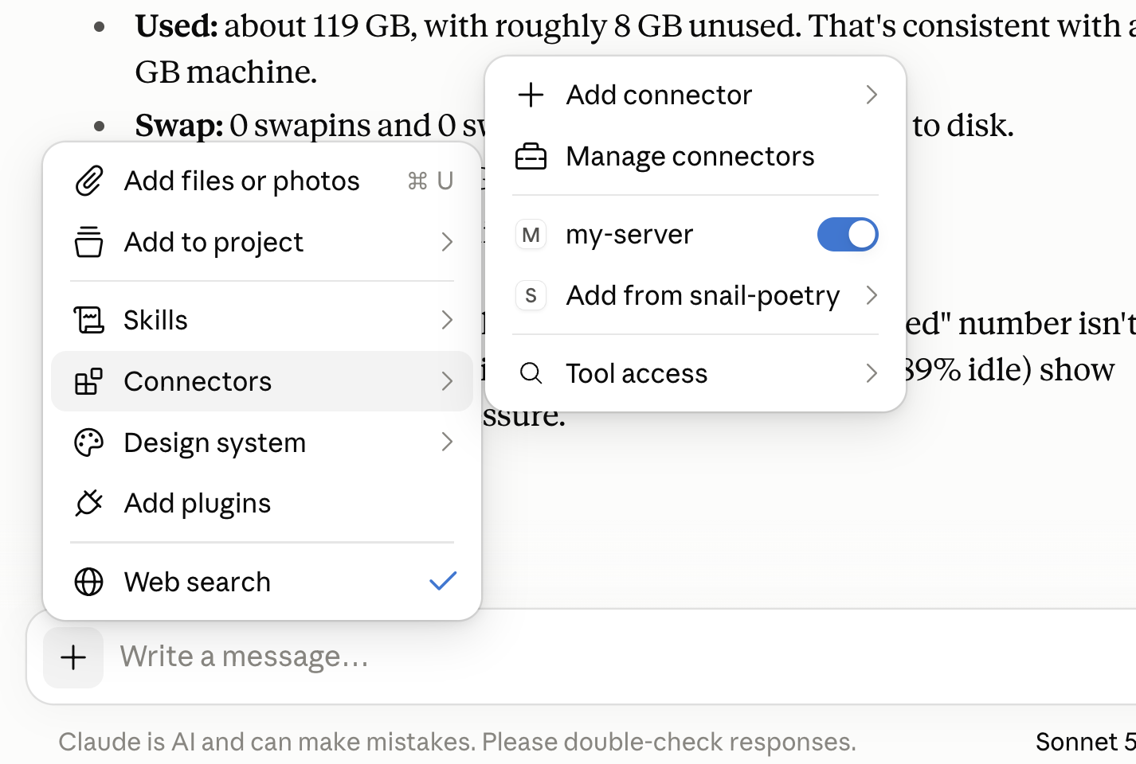

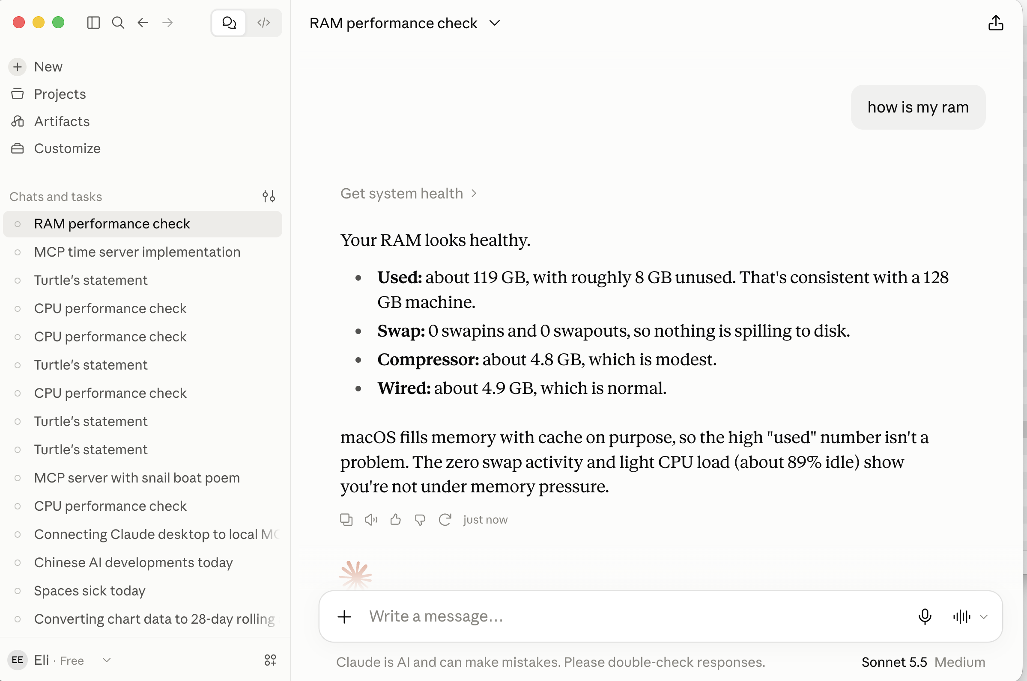

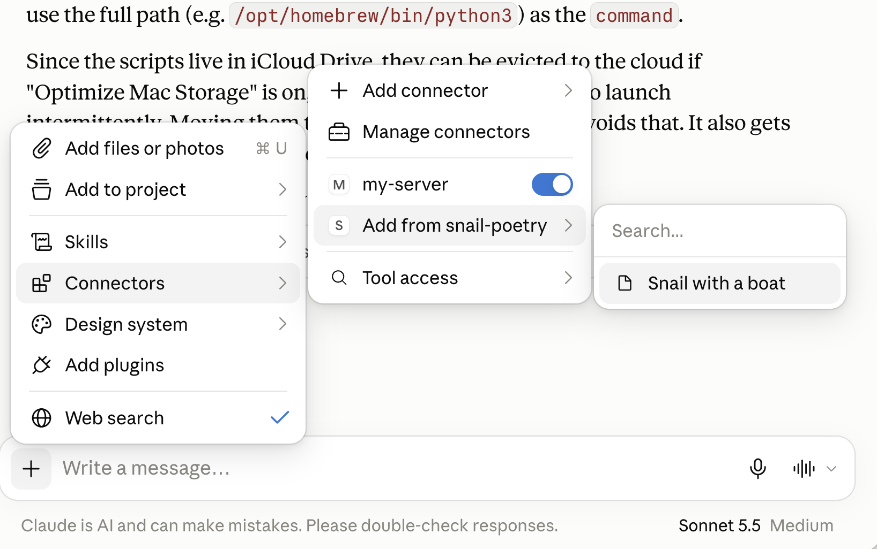



To Add a Remote MCP Server
